Name | MD HAMDAN IBRAHIM
Class | 7 A1

Purpose:
"Skill Assessment Program - Building Strengths Beyond Academics "
This report shows your child's interests and abilities in different school activities. With your (parents) support and our guidance, these strengths can grow into useful life skills. It helps parents notice early signs of talent and areas where extra care or practice can make a big difference.

Key Insights:
The graph below shows how your child is doing in different areas. It tells us what they like more and where we can help them do even better. Blue represents your child, and red represents the class average.
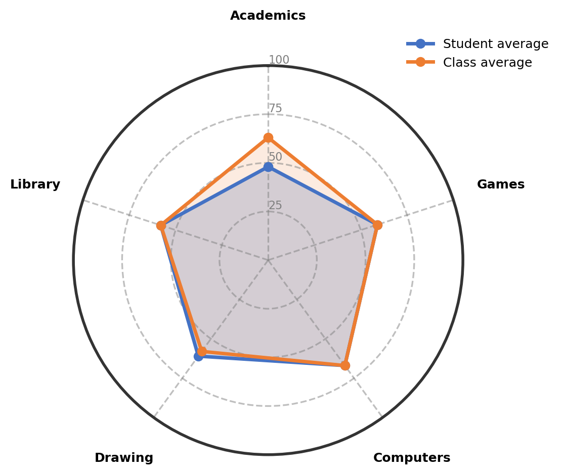

Observations:
The table gives an overview of child's involvement and performance across co-curricular areas.
Interest Area | Engagement (%) | Interest Level | Key Observations
Computers | 67% | Positive and Active Engagement | Shows strong interest in computers and typing. Performs well with motivation and practice, demonstrating active engagement in this area.
Drawing | 61% | Growing Strength in This Area | Shows growing strength in drawing with average participation. The interest is developing in this creative activity.
Games | 59% | Building Confidence Gradually | Enjoys playing shuttle, football, and short cricket. The play shows developing confidence with interest in multiple sports.
Library | 58% | Building Confidence Gradually | Shows good interest in reading and enjoys books. Building confidence gradually while working on vocabulary and reading skills.
Academics | 48% | Emerging Interest | Shows good understanding in science and social studies subjects. The engagement is emerging with positive feedback in these areas.

Recommendations & Growth Opportunities:
Here are some ways to turn your child's interests into long-term strengths:
Strong Interest Area | Potential Careers | Simple Activities to Support
Computers  (67%) | This strong computer interest can connect to various technology fields. Exploring software development, data entry specialist, IT support professional, digital content creator, or web designer is possible. Developing technical skills now builds a strong foundation for many future opportunities. | Enroll in a structured computer typing and basic programming class at a local coaching center to improve typing speed and logical thinking skills
Drawing  (61%) | This growing drawing interest can lead to creative career fields. Exploring graphic designer, illustrator, animator, art teacher, or craft professional is possible. Developing artistic skills enhances observation, creativity, and attention to detail that benefit many areas. | Join a structured drawing class focusing on basic shapes, shading, and perspective to strengthen fundamental art skills

How Parents Can Help:
1. Weekend Exploration (Computers): Dedicate a weekend afternoon to a fun, structured online typing game or basic coding tutorial that teaches keyboard skills and logical thinking, connecting it to the interest in computers.
2. Short Daily Practice (Drawing): Encourage 15 minutes of sketching simple household objects or practicing basic shapes in the evening to maintain the interest in drawing and improve observation skills.
3. Encourage and Talk: Dedicate 10-15 minutes weekly to talk about what excites your child about computers and drawing, and offer your appreciation for their efforts in these activities.

Conclusion:
Your child shows wonderful natural strengths in computers and drawing, with growing confidence in several areas. This stage is perfect for gentle exploration and skill building without pressure. The steady progress in multiple activities shows healthy curiosity and learning behavior. Remember that discovering interests takes time, and every small step forward is valuable. Your support in providing practical opportunities will help these strengths develop naturally.

Notes:
Parents remarks:
Teachers' remarks:

